**Chapter 5**

**Frame Length Optimization**

In FSA, there are two main factors controlling the reading efficiency, and hence the reading time in RFID systems. These two factors are: 1) the number of tags estimation which was discussed in chapter 4. 2) The optimal FSA frame length calculation which will be discussed in details in this chapter. Previous studies have focused on the frame length calculations using the conventional Dynamic Framed Slotted ALOHA algorithms [54]. In such systems, only the answer of a single tag is considered as a successful slot, and if multiple tags respond simultaneously, a collision occurs. Then all the replied tags in collided slot are discarded. In such systems the optimum frame length is equal to the number of tags in the reading area *L* = *n* [83]. However, as mentioned before, modern systems are capable of recovering this collision and converting the collided slot into a successful one [84]. In such a system, it is better to increase the number of collided slots compared to the number of empty slots by decreasing the optimum frame length. This is because these systems are able to gain more from the collided slots compared to the empty slots by converting the collided slots to successful slots. In addition, most of the previous studies assumed constant slot durations regardless the type of the slot. However, the duration of the slots in RFID systems depends on the slot type e.g. empty, successful, or collided. In these systems, the empty slots duration is smaller than than the collided slots duration and smaller than the successful slots duration. Therefore, it is better to increase the frame length, because the losses from the empty slots is less than the losses in the collided slots. In this chapter, the optimum frame length for DFSA will be calculated taking into consideration the collision recovery

55

capability and the difference effects in slots durations. These optimizations will be discussed in different scenarios depending on the RFID system.

This chapter is organized as follows: Section 1 discusses the effect of the dif- ferent slot durations. For this, we will introduce the reading efficiency to have a new performance metric called time aware reading efficiency. Afterwards, a new closed form solution for the optimum frame length, which maximizes the reading efficiency, is proposed. In section 2, the effect of the collision recovery probability with constant coefficients in addition to the time differences in slot duration will be considered. Then, a novel closed form solution for the optimum frame length, which maximizes the system performance, will be presented. Sec- tion 3 illustrates the influence of using multiple collision recovery coefficients assuming constant slots duration, thus, eliciting a new reading efficiency called multiple collision recovery coefficients reading efficiency. Then, a novel closed form solution for the optimum frame length is also derived for this system. Fi- nally, section 4 shows a new closed form solution for the optimum frame length for a system, taking into consideration the time difference in slot durations, in addition to the multiple collision recovery coefficients.

# Time Aware System

In the recent years, some research groups have focused on optimizing the frame length in case of non-equal slot durations: In [85, 86], the authors proposed a numerical solution for the optimal frame length. These methods depend on searching for the optimal frame length which maximizes the reading efficiency. Moreover, they also depend on the tag-to-reader data rate, which make the searching process more complicated. In [87], the mean number of resolved tags in unit time is optimized. This is done by considering the different slot durations. However, this approach is based on a complex multidimensional table look-up, which may be time consuming. [88] suggested to search for the optimum frame length that minimizes the mean time needed to resolve a bunch of tags. However, the author reached a recursive Bellman-equation, which is difficult to be applied in systems with real-time restrictions.

In this section, we propose a novel closed form solution for the optimum frame length in FSA for RFID systems. The proposed solution gives a direct

and linear relation between the frame length *L*, and the number of tags *n* in the reading area. Furthermore, it includes a factor representing the different slot durations.

## Closed Form Solution for Time Aware System

For calculating the proposed optimal time-aware frame size *L* , which consid- ers the different slot durations, it is important to define the time-aware reading efficiency *η* . Let the time-aware reading efficiency be the ratio between the total successful time and the total frame time:

*TA*

*TA*

*ηTA*

= *ts · S ,* (5.1)

*te · E* + *ts · S* + *tc · C*

where *ts · S*, *te · E,* and *tc · E* are respectively the expected total successful, idle, and collided times. Furthermore, *S*, *E*, and *C* are the expected numbers of successful, empty and collided slots. *ts*, *te*, *tc* are respectively the successful, idle, and collided slot durations.

The next step is to derive the new optimum frame length *LT A* under the time-aware environment. According to EPCglobal C1 G2, *L* is always integer. Thus, *LT A* can be optimized by finding the value of *L* which maximizes the time-aware reading efficiency. This is achieved by differentiating the reading efficiency in (5.1) with respect to the frame length *L* and equate the result to zero, where *L* can only has integer values:

*∂ηT A* = 0 (5.2)

*∂L*

According to (3.1), *E*, *S*, and *C* are a function of *L*. Taking into consideration that *te*, *ts, tc* are constants for a given system specification, we get:

(*teE* + *tsS* + *tcC*)*ts ∂* (*S*) *− tsS ∂* (*teE* + *tsS* + *tcC*)

*∂L*

*∂L*

= 0 (5.3)

(*teE* + *tsS* + *tcC*)2

After multiplying both sides by the denominator and dividing by *ts* (non-zero constant), the equation can be simplified to:

(*t E* + *t C*) *∂*

(*S*) + *t S ∂*

(*S*) = *S ∂* (*t E* + *t C*) + *t S ∂*

*S* (5.4)

*e c ∂L*

*s ∂L*

*∂L e c*

*s ∂L*

After subtracting the term which is multiplied by *ts,* the equation finally results

1



Exponential Form

Second Order Taylor Series

0.8

0.6

0.4

0.2

0

0 0.1 0.2 0.3 0.4 0.5 0.6 0.7 0.8 0.9 1



Figure 5.1: Second order Taylor series approximation for *e−* 1 , where *β* = *L*

*β*

*n*

in:

*∂ ∂*

*{teE* + *tcC} ∂L* (*S*) = *S ∂L {teE* + *tcC}* (5.5)

Then, substituting the values of *E*, *S*, and *C* from (3.1) leads to:

1 *− L*

(*L − n −* 1))

 1 *n*

*teL*

1 *− L*

+ *tc*(*L −*

(5.6)

1 *n−*1



 *E*

*C*



*S* 1

*∂*

*× ∂Ln*

11 *−*

*L*

*n−*1

1

=

*n−*1

*n − L*

(*L − n −* 1))



*S* 

*∂* 

*× ∂L*

*teL*

1 *− L*

+ *tc*(*L −*

1 *− L*



1 *n*

1 *n−*1 

 *E* *C*

By simplifying the result, the final exact equation for the proposed time-aware frame length is given by the implicit equation:

1 *n*

*− L*

(

*TA*

\ = (1

*− Ct*

) (1

1 *n*

*,*

\

*− L*

*TA*

(5.7)

where *n* is the number of tags, and *Ct* is the slot duration constant defined

as *Ct* = *te* with 0 *< Ct ≤* 1, as *te ≤ tc* in practical applications. (5.7) shows

*tc*

the exact relation between the proposed time-aware frame length *LT A* and the number of tags *n*, taking into consideration the time difference in the slot durations.

Unfortunately, (5.7) is an implicit equation. We will now derive an approx- imate, but explicit equation. (5.7) can be also expressed as:

1 *−* 1 = (1

*β*

* *Ct*

) 1

1 *n*

* *βn ,*

(5.8)

where *β* = *LTA* . As we are focusing on systems with many tags we can use the approximation

*n*

lim 1

1 *n* = *−* 1

(5.9)

which simplifies (5.7) to:

*n→∞*

*− βn e ,*

*β*

1 *−* 1 = (1 *− C* ) *e−* 1 *.* (5.10)

*β*

*β t*

The analysis of (5.7) indicates that the relevant values for *β* = *LTA* are in the

1

region close to 1. Hence, a Taylor series for *e− β* around one is leads to:

1

*n*

develop

ed which

*e−β :::* 1 *−* 1 + 1

2

(5.11)

*β* 2*β*

According to figure 5.1, this approximation is acceptable in the range of *n ≤* 1 and has almost identical values when the number of tags is less than 0*.*7 the working frame length i.e. *n ≤* 0*.*7.

*L*

*L*

After substituting (5.10) and additional simplifications we get:

*β*2*C − βC* + 0*.*5(*C −* 1) = 0 (5.12)

*t t t*

By solving (5.12), and rejecting the negative solution we finally obtain:

*L* = *n* (1 + / 2 *−* 1\ (5.13)

*TA*

2

*Ct*

The proposed equation gives a linear relation wrt. the number of tags *n*, and includes the slot duration constant *Ct*, which can be easily varied as a function of the transmission rate and the working standard.



Figure 5.2: Slot durations during tag inventory rounds for the ISO 18000-6C standard

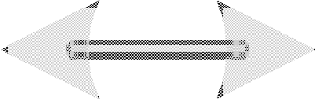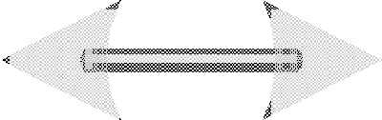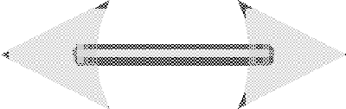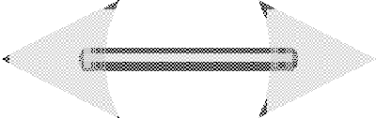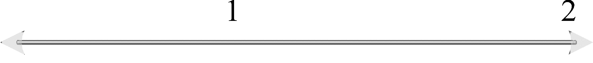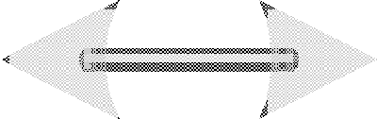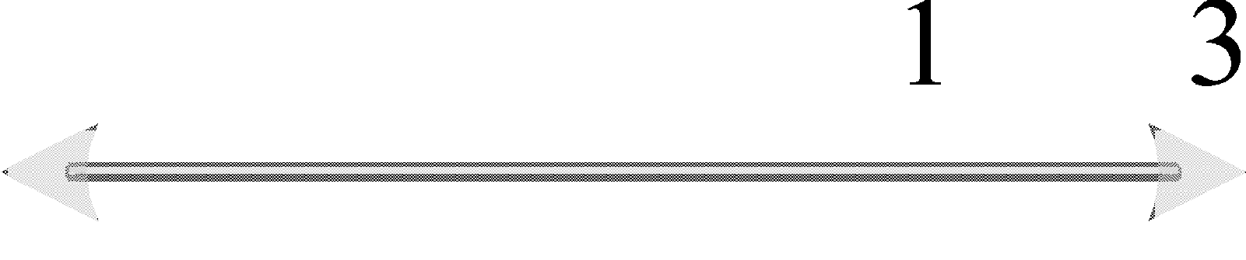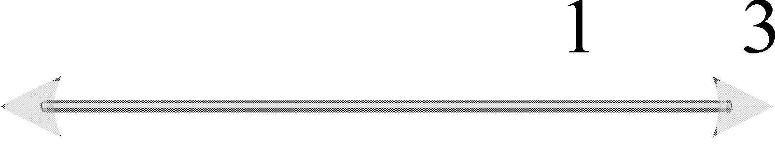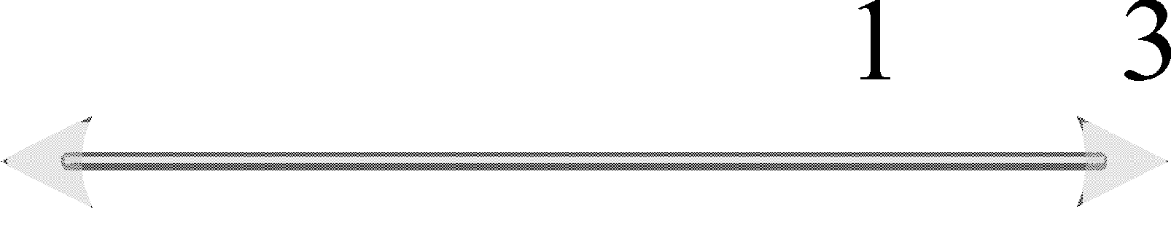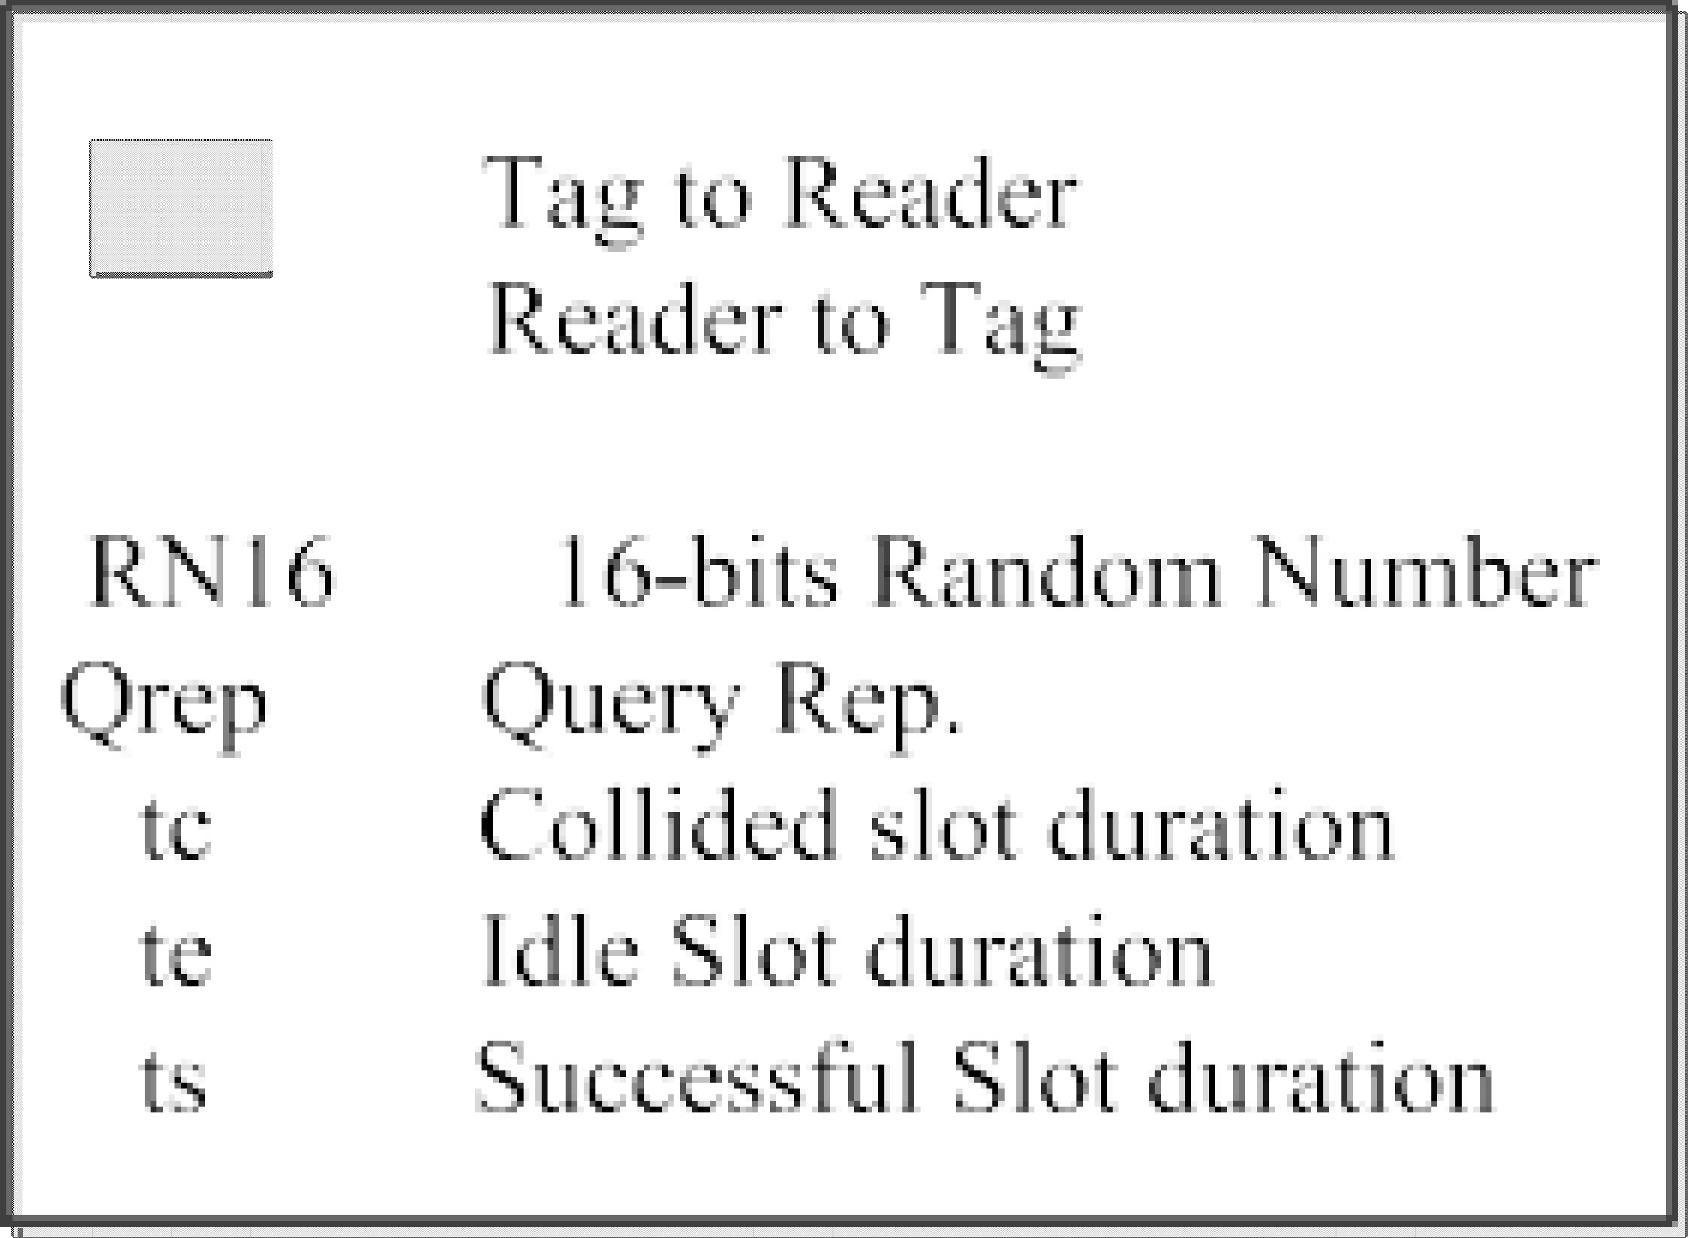

## Slot Duration Constant Calculation For the EPC- global C1 G2

In this section, the calculation method of the slot duration constant *Ct* from the physical layer parameters will be discussed. Figure 5.2 shows the timings of collided and empty slots. Each slot contains different sequences of reader to tag commands and tag replies. Based on the EPCglobal C1 G2 standard [11], the slot duration constant is

*C* = *te ,* (5.14)

*t tc*

As shown in figure 5.2, the empty slot duration *te* is given by:

*te* = *TQRep* + *T*1 + *T*3*.* (5.15)

Here, *TQRep* is the query repeat command time:

*TQRep* = *TFS* + *Tcommand,* (5.16)

with, *TFS* = 3*.*5 *· Tari*, *Tcommand* = 6 *· Tari*, and *Tari* = *DR Tpri*. By substituting

2*.*75

in (5.16) we get

*TQRep* = 3*.*5 *· DR · Tpri,* (5.17)

where *Tari* is reader symbol duration, *Tpri* = 1 , *BLF* is the tag backscatter link frequency and *DR* is the so-called divide ratio constant that can take the two values *DR* = 8 or 64 . Finally, *M* equals to 1*,* 2*,* 4*,* or 8, which represents

3

*BLF*

Table 5.1: Available slots duration constants *Ct* of the EPCglobal C1 G2 stan- dards

|  |  |  |  |
| --- | --- | --- | --- |
| Divide Ratio: *DR* | Modulation: *M* | Pilot Length: *np* | *Ct* |
| 8 | 1 | 0 | 0*.*47 |
| 12 | 0*.*41 |
| 2 | 4 | 0*.*35 |
| 16 | 0*.*28 |
| 4 | 4 | 0*.*23 |
| 16 | 0*.*18 |
| 8 | 4 | 0*.*14 |
| 16 | 0*.*1 |
| 64*/*3 | 1 | 0 | 0*.*7 |
| 12 | 0*.*65 |
| 2 | 4 | 0*.*57 |
| 16 | 0*.*5 |
| 4 | 4 | 0*.*43 |
| 16 | 0*.*35 |
| 8 | 4 | 0*.*3 |
| 16 | 0*.*22 |

the modulation types FM0, Miller 2, 4, or 8, respectively. *T*1 is the time from the reader transmission to the tag response, which can be expressed as:

*T*1 = max *{DR · Tpri,* 10 *· Tpri}* (5.18)

Next, *T*3 is the time that the reader waits after *T*1 before issuing another com- mand. As it has no constraints, it can be assumed to be zero. After substituting (5.17) and (5.18) in (5.15), *te* can be expressed as:

*te* = *Tpri ·* (3*.*5 *· DR* + max *{DR,* 10*}*) *.* (5.19)

Next, the collided slot duration *tc* is given by:

*tc* = *TQRep* + *T*1 + *T*2 + *TRN* 16*,* (5.20)

where *T*2 is the reader response time starting from the end of the tag response,

*T*2 = 6 *· Tpri*, and *TRN* 16 is the duration of 16 bits temporary data, 6 bits

preamble, *np* pilot tones, i.e. *TRN* 16 = (22 + *np*) *· Tpri*. Therefore, *tc* can be expressed as:

*tc* = *Tpri ·* (3*.*5 *· DR* + max *{DR,* 10*}* + 6 + 22 *· M* + *np · M* ) *.* (5.21)

From (5.19) and (5.21), the final expression of *Ct* is:

*Ct* = 3*.*5

* *DR*

3*.*5 *· DR* + max *{DR,* 10*}*

+ max *{DR,* 10*}* + 6 + 22 *· M*

+ *np · M*

*.* (5.22)

Table 5.1 shows the values of the slot duration constant of the EPCglobal C1 G2 standards. According to table 5.1, the slot duration constant *Ct* varies from 0*.*1 to 0*.*7, and this affects the optimum frame length directly.

## Closed Form Solution vs. Numerical Solution

Figure 5.3a displays the behavior of the proposed frame length formula in (5.13) compared to the numerical solution in [88] for the complete range of the slot du- ration constant *Ct* for 0 *< Ct ≤* 1. In the simulation, a fixed number of *n* = 100 tags is used. According to figure 5.3, the proposed equation approaches the nu- merical solution proposed in [88] in the full range of *Ct* with very small bias coming from the Taylor series approximation in (5.11). According to the EPC- global C1 G2 standard [11] the frame length is allowed to take only quantized values (power of 2). Thus, in figure 5.3b only the next quantized frame length is selected, which decreases the effect of the Taylor approximation. According to 5.3b, the proposed frame length fully match the numerical solution in the full range of *Ct*.

## Mean Reading Time Reduction

In conventional FSA systems, the slots durations are considered as constant slots. Thus, the total identification time is calculated by counting the average total number of slots needed to identify the complete number of tags in the reading area. Then, according to literature, the mean reduction in number of slots is calculated according to the following equation:

*ζ* % = ( Slot*sconv. −* Slot*sproposed* \ *×* 100 (5.23)

Slot*sconv.*

800

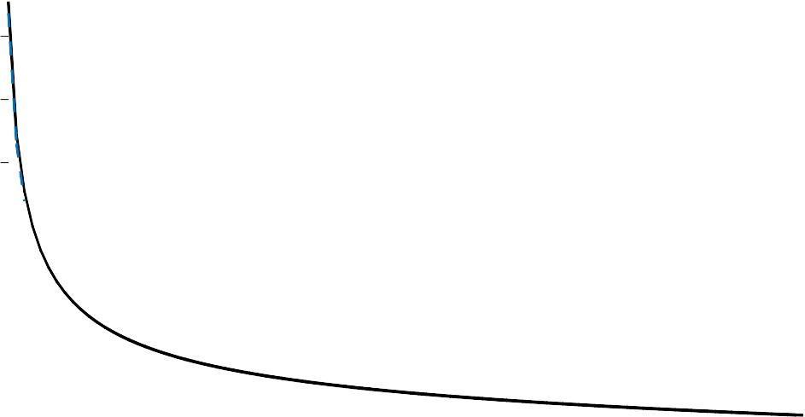

Proposed closed form

Numerical solution

700

600

Optimum Frame Length

500

400

300

200

100

0 0.1 0.2 0.3 0.4 0.5 0.6 0.7 0.8 0.9 1

Ct

1. Non-quantized Frame length

1200



Proposed Closed Form

Numerical Solution

1000

Quantized Optimum Frame Length

800

600

400

200

0

0 0.1 0.2 0.3 0.4 0.5 0.6 0.7 0.8 0.9 1

Ct

1. Quantized Frame Length

Figure 5.3: Optimum frame length *LT A* as a function of the slot duration constant *Ct* (*n* = 100 tags). The conventional case with identical slot durations corresponds to *Ct* = 1.

In time aware systems, the slots durations are variable. Therefore, the total identification time can only be calculated as time in seconds. Afterwards, the percentage of mean reading time reduction is calculated as follows:

*ζ* % = T*conv. −* T*proposed* 100 (5.24)

( T \ *×*

*t*

*conv.*

Figure 5.4 shows simulation results for the reading time reduction of the pro- posed optimal time-aware frame length *LT A* wrt. the classical optimal frame length *L* = *n* as a function of the slot duration constant *Ct*. These simulations assume a perfect knowledge of the number of tags *n*. According to the figure, *Ct* = 0 means that the idle slot duration time *te* = 0. In this case, the optimum frame length *L* is theoretically infinite. According to the EPCglobal C1 G2 standard [11], the frame length is allowed to take only quantized values (power of 2). According to figure 5.3b, the number of tags in the reading area *n* = 100 tags. Thus, the quantized optimum frame length is *L* = 1024 slots. In this case, the proposed time-aware frame length can reduce the average reading time up to 12% compared to the conventional optimization criterion. With *Ct* = 1, which means that the slot durations are of identical length (the conventional FSA), the efficiency of the classical optimization, i.e. *L* = *n* is obtained.

In practice, the number of tags in the interrogation region is unknown. Hence, the anti-collision algorithms in real RFID systems consist of two stages: one estimates the number of tags in the interrogation area *n*ˆ whereas the other calculates the optimal frame length *Lopt* based on *n*ˆ for maximizing the reading efficiency. Figure 5.5 illustrates the mean reduction of the reading time using the proposed time-aware frame length for the proposed ML number of tags estimation and some well-known tag estimation algorithms using the value of the slot duration constant *Ct* = 0*.*2. The main purpose of these simulations is to show the practical effect on the reading time by working with the proposed frame length using different tag estimation algorithms. Each curve presents the mean reduction of the reading time between the proposed frame length and the conventional frame length *L* = *n* using the same estimation algorithm. When a simple tag estimation technique is used like Lower bound [54] or Schoute [52], we can reduce the reading time in the order of 10 to 12 %, thereby gaining around 9 % for better estimation algorithms like [89] and [90], and at last gaining 6 %

12

|  |  |  |  |  |  |  |  |  |  |
| --- | --- | --- | --- | --- | --- | --- | --- | --- | --- |
|  |  |  |  |  |  |  |  |  |  |
|  |  |  |  |  |  |  |  |  |  |
|  |  |  |  |  |  |  |  |  |  |
|  |  |  |  |  |  |  |  |  |  |
|  |  |  |  |  |  |  |  |  |  |
|  |  |  |  |  |  |  |  |  |  |

10

Mean reading time reduction %

8

6

4

2

0

0 0.1 0.2 0.3 0.4 0.5 0.6 0.7 0.8 0.9 1

Slot duration constant C

t

Figure 5.4: Percentages of saving time using the proposed TAFSA for an ideally known number of tags, *Ct* = 1 is the conventional FSA

upon using the proposed ML estimation algorithm. According to figure 5.5, the better estimation algorithms, the less reading time reduction, because it decreases the number of iterations in FSA process. However, using a non- accurate number of tags estimation algorithms, FSA needs more iterations, with more FSA frame length adaptations. That gives more importance for the proposed formula compared to the classical frame length adaptations.

# Time and Collision Recovery System

As mentioned in chapter 4, modern RFID readers are able to decode one of multiple collided tags, which is called the collision recovery capability *α*. Ac- cording to the literature we can divide the previous research, which considered the collision recovery capability in the frame length optimization, into three different groups: The first group considered only the average collision recov- ery probability for the frame length optimizations, such as [58]. The authors proposed a closed form equation for the optimum frame length maximizing the reading throughput per frame. The second group observed only the different

30



Biased chebyshev

MFML

proposed ML estimation Perfect estimation

Lower bound

Schoute

28

26

Mean reading time reduction

24

22

20

18

16

14

12

10

8

6

4

2

0

0 100 200 300 400 500 600 700 800 900 1000

Number of tags

Figure 5.5: Percentages of saving time using the proposed TAFSA compared to the conventional frame length *L* = *n* for different anti-collision algorithms using *Ct* = 0*.*2

slot durations, such as [88, 91] and as shown in the first proposal in the previ- ous section. However, no closed form solution for the optimum frame length was derived. They calculated the optimum frame length numerically. The third group contemplated the different slot durations and the collision recovery probability, such as [86,92,93]. Both [86,92] gave numerical solutions for the op- timum frame length versus the collision recovery probability and the number of tags. The main problems of their numerical solutions are the multiple degrees of freedom. The solutions require a complex multidimensional look-up table that has to consider all possible degrees of freedom. [93] uses curve fitting to find a closed form solution for the optimum frame length at a specific collision recovery probability and timing. However, this solution can not be generalized for all values of slot’s timing and collision recovery probabilities.

In this section, a closed form solution for the optimum frame length will be derived by optimizing the reading throughput per frame, which does not require any look-up table [86, 92]. In addition, we take into consideration the average collision recovery probability and the different slot durations. Moreover, the calculation method of the collision recovery probability based on the physical layer will be clarified.

## Closed Form Solution for Time and Collision Re- covery System

Now, the proposed optimal time and collision recovery aware frame size *L* will be derived, which considers the different slot durations and the collision recov- ery probability. Thus, we will first introduce a new reading efficiency called Time and Collision Recovery Aware reading efficiency *η* . The main proper- ties of this efficiency are the consideration of the different slot durations and the average collision recovery probability.

*TCA*

*TCA*

In this efficiency, we added the average collision recovery probability *α* to the time aware efficiency in (5.1). Therefore the time and collision recovery probability aware efficiency can then be written as:

*η*

*TCA*

= *ts · Sc .* (5.25)

*te · Ec* + *ts · Sc* + *tc · Cc*

where *Ec*, *Sc* and *Cc* are respectively the expected number of empty, successful, an collided slots after adding the effect of the collision recovery probability *α*. Their relation is given by:

*Ec* = *E, Sc* = *S* + *α · C, Cc* = (1 *− α*) *· C.* (5.26)

The target is to find the optimum frame length *LT CA* which maximizes the proposed reading efficiency in 5.25. This is achieved by differentiating the

reading efficiency *η*

the result to zero.

*TCA*

of (5.25) with respect to the frame length *L* and equate

Clearly, the frame length *L* is an integer value. Therefore, differentiating the equation is not fully correct. However, we will later show that the resulting error is negligible. According to (5.26), *Ec*, *Sc*, and *Cc* are a function of *L*. However, *te*, *ts, tc* are constants for a given system configuration. Thus, the equation can be simplified to

(*teEc* + *tsSc* + *tcCc*)*ts d* (*Sc*) *− tsSc d* (*teEc* + *tsSc* + *tcCc*) = 0 (5.27)

*dL*

*dL*

(*teEc* + *tsSc* + *tcCc*)2

After multiplying both sides by the denominator and dividing by *ts* (non-zero constant), and subtracting the term, which is multiplied by *ts,* the equation results in:

(*t E* + *t C* ) *d* (*S* ) = *S*

*d* (*t E* + *t C* ) *.* (5.28)

*e c c*

*c dL c*

*c dL e c c c*

Then, the substitution by the values of *Ec*, *Sc*, and *Cc* from (5.26) leads to the final exact equation for the proposed time and collision recovery probability aware frame length:

(1 *− α*) *·* (1 *−* ) + *α · C*

*n*

*·* 1 *−* 1 (5.29)

*LTCA*

+ ( 1) (1

*Ct −*

*·*

*t*

) 1

*− α*

*·*

*LTCA*

1 *n* = 0

*− L*

*TCA*

*,*

where *n* is the number of tags, and *Ct* is the slot duration constant defined as

*Ct* = *te* . Equation (5.29) shows the exact relation between the proposed colli-

*tc*

sion recovery and time-aware optimum frame length *L*

*CTA*

and the number of

tags *n*. This equation takes into consideration the collision recovery probability and the different slot durations. However, this solution depends on a recursive equation. For reaching an explicit equation, (5.29) can be expressed as:

(1 *− α*) *·* (1 *−* 1 ) + *α · Ct ·* 1 *−*  (5.30)

1

+ (*Ct −*

*β*

1) *·* (1

* *α*)

*·* 1

*βn*

1 *n*

= 0

* *βn ,*

where *β* = *LTCA* . As focusing on systems with a large number of tags *n*, again the following approximation can be used

*n*

lim 1

1 *n* = *−* 1

(5.31)

which simplifies (5.30) to:

*n→∞*

*− βn e ,*

*β*

(1 *− α*) *·* 1 *−* 1 + *α · Ct ·* 1 *−*  (5.32)

1

*β βn*

+(1 *− α*) *·* (*Ct −* 1) *e−β* = 0*.*

1

The analysis of (5.29) indicates that the relevant values for *β* = *LT CA* are in the

*n*

region close to one [86]. Hence, we can develop a Taylor series for *e−* 1

*β*

around

one which leads to:

*e−β*

1

*:::* 1 *−* 1 + 1 *.* (5.33)

2

*β* 2*β*

After substituting (5.32) and some additional simplifications, we get:

*β*2*C*

*− βC* (1 + *α* ) *−* 0*.*5 (1 *− α*) *·* (1 *− C* ) = 0*.* (5.34)

As *α «* 1*,* (5.34) can be expressed as:

*t*

*t*

*n*

*t*

*n*

*β*2*Ct − βCt −* 0*.*5 (1 *− α*) *·* (1 *− Ct*) = 0*.* (5.35)

By solving (5.35) and rejecting the negative solution we finally reach the final solution:

*L* = *n* ((1 *− α*) + /(1 *− α*)2 + 2 (1 *− α*) *·* (1 *− C* )\ *.* (5.36)

*TCA*

2

*Ct*

*t*

As the optimization of (5.1) is a convex optimization problem, and there exits only one non-negative solution of (5.35), (5.36) leads to the global optimum. According to the literature, [92] is the only work which used the same perfor-

mance metric *η*

*TCA*

to get the optimum frame length. However, in this work

the authors did not propose any closed form solution and they have to rely on multi-dimensional look-up tables.

As mentioned before, the value of *α* strongly depends on the receiver type and the SNR. The value of collision recovery *α* could be one of the values of figure 4.5, depending on the receiver type and the value of SNR.

## Closed Form Solution vs. Numerical Solution

We will now compare the proposed closed form equation in (5.36) to the nu- merical results in [92]. Figure 5.6a shows both algorithms for the full range of the slot duration constant *Ct*. Assuming a fixed number of *n* = 100 tags, figure 5.6a indicates that the proposed closed form approaches the numerical solution for different *α* in the full range of *Ct*. Due to the Taylor series approximations in 5.33, there are slight differences between the proposed closed form and the numerical solution, where the numerical is the exact solution. As previously mentioned, the EPCglobal C1 G2 standard [11] frame length is allowed to take

500



Proposed closed form using =0.25

Numerical solution using =0.25

Proposed closed form using =0.5

Numerical solution using =0.5

Proposed closed form using =0.75

Numerical solution using =0.75

400

Optimum frame length (LTCA)

300

200

100

0

0 0.1 0.2 0.3 0.4 0.5 0.6 0.7 0.8 0.9 1

C

t

1. Non-quantized Frame Length

1024



)

QTCA

896

Quantized Optimum frame length (L

768

640

512

Proposed closed form using =0

Numerical solution using =0

Proposed closed form using =0.25

Numerical solution using =0.25

Proposed closed form using =0.75

Numerical solution using =0.75

384

256

128

0

0 0.1 0.2 0.3 0.4 0.5 0.6 0.7 0.8 0.9 1

C

t

(b) Quantized Frame Length

Figure 5.6: Optimum frame length *L*

*TCA*

as a function of the slot duration

constant *Ct* (*n* = 100 tags) for the capture probabilities *α* = 0*.*25*,* 0*.*5*,* 0*.*75.

20

|  |  |  |  |  |  |  |  |  |  |  |
| --- | --- | --- | --- | --- | --- | --- | --- | --- | --- | --- |
|  |  |  |  |  |  |  |  | =0.7    =0.4 | | |
|  |  |  |  |  |  |  |  |
|  |  |  |  |  |  |  |  |  | =0.1 | |
|  | |  |
|  |  |  |  |  |  |  |  |  | |  |
|  |  |  |  |  |  |  |  |  | |  |
|  |  |  |  |  |  |  |  |  | |  |
|  |  |  |  |  |  |  |  |  | |  |
|  |  |  |  |  |  |  |  |  | |  |
|  |  |  |  |  |  |  |  |  | |  |
|  |  |  |  |  |  |  |  |  | |  |



18

16

Mean reading time reduction %

14

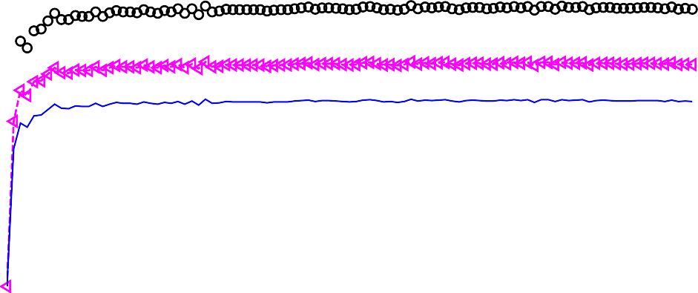

12

10

8

6

4

2

0

0 100 200 300 400 500 600 700 800 900 1000

No. of tags {n)

Figure 5.7: Reading time reduction using the proposed TCRA compared to the conventional frame length *L* = *n* for perfect number of tags estimation using *Ct* = 0*.*2 and different values of *α*

only quantized values (power of 2). Thus, the next quantized frame length is selected and this will eliminate the approximation error. Figure 5.6b shows that the proposed frame length fully match the numerical solution in the full range of *Ct*.

## Mean Reduction of Reading Time

As mentioned previously, the most common performance metric of comparison is the mean reduction in reading time compared to the conventional frame length *L* = *n*. Figure 5.7 illustrates simulation results for the reading time reduction of the proposed optimal TCRA frame length *LT CA* wrt. the classical optimal frame length *L* = *n* for *Ct* = 0*.*2 and different values of the collision recovery probability *α*. These simulations assume a perfect knowledge of the number of tags *n*. According to figure 5.7, the mean reading time reduction increases when the value of *α* increases, which gives more advantage to the proposed solution compared to the conventional one.

Figure 5.8 shows the mean reduction of the reading time using the proposed

50



Lower bound Schoute Biased chebyshev MFML

proposed ML estimation Perfect estimation

45

Mean reading time reduction

40

35

30

25

20

15

10

5

0

0 100 200 300 400 500 600 700 800 900 1000

Number of tags

Figure 5.8: Percentages of saving time using the proposed TCRA compared to the conventional frame length *L* = *n* for different anti-collision algorithms using *Ct* = 0*.*2 and *α* = 0*.*6

TCRA frame length compared to the conventional frame length *L* = *n* taking into consideration the effect of the number of tags estimation algorithms. Ac- cording to figure 5.8, the minimum mean reading time reduction is obtained upon having perfect knowledge of the number of tags in the reading area, be- cause it results in the minimum number of iterations for FSA process.

# Multiple Collision Recovery System

To simplify the analysis, previous sections considered systems with equal colli- sion recovery probability coefficients regardless the number of collided tags per slot. For example, the probability to resolve two collided tags is equal to the probability to resolve three or four collided tags per slot. However, in practice the probability to recover one tag from two collided tags is more than the prob- ability to identify single tag from three collided tags. Therefore, in this section, the collision recovery probability will be considered as a variable coefficient *αi*, where *i* is the number of collided tags per slot.

In this section, a new reading efficiency metric called Multiple Collision Recovery Coefficients Reading Efficiency *ηMCRC* is proposed. The proposed efficiency includes a unique collision resolving coefficient for each number of collided tags. Hence, a novel closed form solution for the optimum FSA frame

length is proposed which maximizes the proposed efficiency metric. Then, cal- culations of these coefficients based on a simple RFID reader model to show how the proposed system could be applied on real-life applications.

## Closed Form Solution For Multiple Collision Re- covery Aware System

This section will introduce a new FSA efficiency metric called Multiple Collision Recovery Coefficients Reading Efficiency *η* . Afterwards, a closed form solution for the new optimum frame length *LMCRC* under multiple collision recovery coefficients environment will be presented.

*MCRC*

The main contribution of this efficiency is that it contains a specific colli- sion recovery coefficient *αi* for each probability of collision *Pcol.*(*i*). These new

coefficients indicate the ability of the reader to recover one tag from *i* collided tags. The proposed reading efficiency *η* is expressed as:

*MCRC*

*n*

*ηMCRC* = *P* (1) + *αiPcol.*(*i*)*.* (5.37)

*i*=2

Figure 5.9 presents the distribution of the average collision probability in a frame of length 0*.*5 *· n ≤ L ≤* 2 *· n* uniformly. The simulations results are done using monte-carlo simulations for the FSA algorithm under condition of frame of length 0*.*5 *· n ≤ L ≤* 2 *· n* uniformly, which is the practical range of the frame length in RFID systems according to [86].

As shown in figure 5.9, the probability that the collided slot comes from two, three, or four collided tags is equal to *Pcol.*(2) + *Pcol.*(3) + *Pcol.*(4) "" 96% ,

and for the remaining tag collisions },*n*

*i*=5

*Pcol.*

(*i*) "" 4%. Moreover, the values of

the collision recovery coefficients *αi, i >* 4 are practically very small.

Therefore, the proposed *η* for the practical RFID environment can be expressed as follows:

*MCRC*

*ηMCRC* = *P* (1) + *α*2*Pcol.*(2) + *α*3*Pcol.*(3) + *α*4*Pcol.*(4)*,* (5.38)

where *α*2, *α*3, and *α*4 are respectively the second, third, and fourth collision recovery coefficients.

The next step is to derive a closed form solution for the new optimum

0.7

0.6

0.5

Probability of Occurrence

0.4

0.3

0.2

0.1

0 2 3 4 5 6 7 8 9

Number of Collided Tags per Slot

Figure 5.9: Distribution of collision probability for a collided slot in FSA, under condition of *n ≤ L ≤* 2*n*

2

frame length *LMCRC* under multiple collision recovery coefficients environment. *LMCRC* can be optimized by finding the value of *L* which maximizes *η* . According to [94], if *L »* 1, and *n » i*, we can assume a Poisson distribution:

*MCRC*

*P* (*i*) "" 1 *· β−i · e−* 1 *,* (5.39)

*β*

*i*!

where *β* = *L* . After substituting (5.39) in (5.38) we get:

*n*

*η* = *e−* 1 *· β−*1 + *α*2 *β−*2 + *α*3 *β−*3 + *α*4 *β−*4 *.* (5.40)

*β*

*MCRC*

2 6 24

Now we have to find the value of *β* which maximizes *η*

*MCRC*

. This is achieved

by differentiating the reading efficiency in (5.40) with respect to *β* and equate the result to zero. After differentiating, the equation can be simplified as:

*−* 1 ( *−*2 *−*3

*β−*4

*β−*5

*−e β · β* + *β* (*α*2 *−* 1) +

2 (*α*3 *− α*2) +

6 (*α*4 *− α*3) (5.41)

*β−*6*.α*4 \

*−*

= 0*.*

24

24

Multiplying the equation by *−e β · β*6, it finally results in:

1

1 *β*4 + (*α*2 *−* 1)*β*3 + (*α*3 *− α*2) *β*2 + (*α*4 *− α*3) *β − α*4

= 0*.* (5.42)

*a*

*b*

2

*c*

6

*d*

24

*e*

Equation (5.42) has four roots [95]:

*β*1 2 = *− b*

*− S ±* 0*.*5 III*−*4*S*2 *−* 2*P* + *q*

(5.43)

*,* 4 *a*

*S*

*X*

*β*3 4 = *− b*

+ *S ±* 0*.*5 III*−*4*S*2 *−* 2*P − q ,*

*S*

*,* 4*a*

*S*

*Y*

where *P* = 8*ac−*3*b*2 , *q* = *b*3 *−*4*abc*+8*a*2 *d*

8*a*2 8*a*3

and, *S* = 0*.*5I*−* 2 *P* + 1 (*Q* + *6*0 , *Q* = I3

3

3*a*

*Q*

*6*1+*√6*2 *−*4*6*3 .

with, *D.*0 = *c*2 *−* 3*bd* + 12*ae*, *D.*1 = 2*c*3 *−* 9*bcd* + 27*ad*2 *−* 72*ace*

2

1

0

Based on practical ranges for the collision recovery coefficients, *αi* , 0 *≤ αi ≤* 1, and *α*2 *≥ α*3 *≥ α*4. Therefore, we can proof that the signs of the polynomial coefficients are constant and not changing in all ranges of *αi* and can be presented as follows: *a >* 0, *b <* 0, *c <* 0, *d <* 0, and *e <* 0.

According to Descartes’ rules of sign [80], there is only one valid real positive solution for the equation. After analyzing (5.42) using Descartes’ rules of sign [80], the proposed closed form optimum frame length *LMCRC* under the multiple collision recovery coefficients environment is:

*LMCRC*

= *− b*

+ *S* + 0*.*5I*−*4*S*2 *−* 2*P − q*  *· n* (5.44)

According to (5.44), the proposed equation gives a linear relation wrt. the number of tags *n*, and includes the effect of different collision recovery coeffi- cients. In case that the RFID reader has no collision resolving capability, i.e. *α*2 = *α*3 = *α*4 = 0, the proposed formula gives *LMCRC* = *n*, which is identical to the frame length in the conventional case. When the RFID reader has a full and equal collision resolving capability for the two, three, and four collided tags per slot, i.e. *α*2 = *α*3 = *α*4 = 1, the proposed formula gives *LMCRC* = 0*.*452 *· n*,

4*a*

*S*

0.9

|  |  |  |  |  |  |  |  |  |  |  |
| --- | --- | --- | --- | --- | --- | --- | --- | --- | --- | --- |
|   2  3  4 | |  |  |  |  |  |  |  |  |  |
|  |  |  |  |  |  |  |  |  |
|  |  |  |  |  |  |  |  |  |
|  |  | |
|  |  | |  |  |  |  |  |  |  |  |
|  |  | |  |  |  |  |  |  |  |  |
|  |  | |  |  |  |  |  |  |  |  |
|  |  | |  |  |  |  |  |  |  |  |
|  |  | |  |  |  |  |  |  |  |  |

0.8

Collision Recovery Coefficients

0.7

0.6

0.5

0.4

0.3

0.2

0.1

0 2 4 6 8 10 12 14 16 18 20

SNR [dB]

Figure 5.10: Simulation results for the average collision recovery coefficients versus SNR using the strongest tag reply receiver. *α*2, *α*3, and *α*4 are respec- tively the collision recovery probability or two, three, and four collided tags per slot.

which matches the results in [59].

## Collision Recovery Coefficients Calculations

Now the calculation of the collision recovery coefficients *α*2, *α*3 and *α*4 will be clarified, which are the main optimization variables in our proposal. The values of these coefficients are strongly dependent on the receiver type. Calculations of the collision recovery coefficients are done based on an RFID reader model that utilizes the capture effect. The reader resolves the collision based on the strongest tag reply. Therefore, the collision can be resolved with a certain probability, if the strongest tag reply is stronger than the summation of the other collided tags at the same slot.

The main advantage of this reader is that it does not need any channel state

information (CSI) to recover the strongest tag. According to EPCglobal C1G2 standard [11], collisions in RFID systems occur only within the 16 bits packet called *RN* 16. If any single bit error occurs in this packet, the total packet

0.5



Numerical Solution

Proposed Formula

0.95

0.9

0.85

0.8

0.75

0.7

0.65

0.6

0.55

L/n

0 2 4 6 8 10 12 14 16 18 20

SNR [dB]

Figure 5.11: Frame length comparison between the proposed formula in (5.44) and the numerical solution for different SNR values.

has to be considered lost. Therefore, the meaning of the collision recovery probability coefficients *αi* is the probability that the RFID reader can identify a complete *RN* 16 packet from *i* collided tags. Therefore, the collision recovery coefficient can be expressed as *αi* = (1 *− PERi*), where *PERi* is the Packet Error Rate for *i* collided tags. In this work, we measure the SNR for each slot, then we calculate the average SNR per frame as *E |h|*2 *·x*2 , where *σ* is the standard deviation of the Additive White Gaussian Noise (AWGN) per slot, and at last, we used normalized signal power, i.e. *E {x*2*}* = 1. Based on [81], we assumed that the equivalent channel coefficients *h* follow Rayleigh fading. The channel coefficients are independent zero mean circularly symmetric complex Gaussian random variables with normalized energy *E |h|*2 = 1, and all tags are statistically identical, which means all of them experience the same average path loss. Therefore, the average SNR per frame is *E* 1 .

*σ*2

J l

J l

*σ*2

J l

Figure 5.10 shows the values of the collision recovery coefficients versus the average SNR per frame using the strongest tag reply receiver. In these simulations, a sampling frequency of *fs* = 8 MHz is used, and the tags used FM0 as an encoding scheme. Finally, to clarify the worst case effect of the collision recovery coefficients, we used the highest symbol rate BLF = 640 kHz.

20

SNR=4dB

SNR=8dB

SNR=10dB

18

16

Mean reading time reduction%

14

12

10

8

6

4

2

0

0 100 200 300 400 500 600 700 800 900 1000

No. of tags {n)

Figure 5.12: Mean reading time reduction using the proposed MCR compared to the conventional frame length *L* = *n* for perfect number of tags estimation using *Ct* = 0*.*2 and different *SNR* values

## Closed Form Solution vs. Numerical Solution

For each RFID reader, each SNR leads to corresponding values for the collision recovery coefficients *α*2, *α*3 and *α*4. Figure 5.11 shows a comparison between the proposed formula (5.44) and the numerical solution which maximizes the reading efficiency in (5.40) versus the SNR. Both simulations used the same receiver model, which is the strongest tag reply receiver. According to figure 5.11, the proposed formula gives identical results compared to the numerical solution at the complete SNR range.

## Mean Reading Time Reduction

The total average number of slots needed to identify a complete bunch of tags is calculated using the strongest tag reply receiver in [57]. FSA with initial frame length *Lini.* = 16 is used as an anti-collision algorithm. Figure 5.12 illustrates a comparison between the percentages of saving time using the proposed MCR and the conventional frame length *L* = *n* assuming perfect number of tags

40 Perfect Estimation

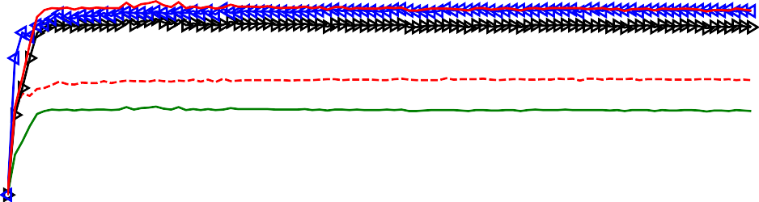

35 Proposed ML Estimation

MFML

Mean reading time reduction%

30 Biased Chebyshev

Schoute

25 Lower bound

20

15

10

5

0

0 100 200 300 400 500 600 700 800 900 1000

No. of tags {n)

Figure 5.13: Mean reading time reduction using the proposed MCRA compared to the conventional frame length *L* = *n* using different anti-collision algorithms with *Ct* = 0*.*2 and *SNR* = 4 dB

estimation. The simulation uses *Ct* = 0*.*2 and different *SNR* values. According to figure 5.12, when the value of the *SNR* increases, the collision recovery probability increases. Hence, the mean reading time reduction also increases.

Figure 5.13 shows the percentages of saving time with the proposed MCR compared to the conventional frame length *L* = *n* using different anti-collision algorithms with *Ct* = 0*.*2 and *SNR* = 4 dB.

In this section, the FSA reading efficiency is proposed for equal slot duration system with multiple collision recovery coefficients. However, practically, there are differences in the slot durations depending on the slot type. Therefore, in the following section, the FSA reading efficiency will consider the differences in slot durations as well as the differences in the collision recovery coefficients.

# Time and Multiple Collision Recovery Sys- tem

In this section we present a new FSA reading efficiency metric called time aware multiple collision recovery coefficients reading efficiency *η* . The main contribution in this new efficiency is that it contains a unique collision recovery coefficient *αi* for each probability of collision *P* (*i*). These new coeffi- cients indicate the ability of the reader to recover one tag from *i* collided tags, where this ability varies based on the number of collided tags. Moreover, it takes into consideration the different slot durations.

*TAMCRC*

## Closed Form Solution for Time Multiple Collision Recovery Aware System

According to figure 5.9, the probability that a collision results from two or three collided tags is approx. 85%. Moreover, the values of the collision recovery coefficient *αi* when *i ≥* 4 (i.e. 4 or more collided tags) will be small. Therefore, only up to three collided tags will be considered. The next step is normalizing the slot duration *tk* of successful and collided tags to unity. Furthermore, it will be assumed that empty slots are shorter than successful slots (i.e. *t*0 *≤ tk*), which is the case for practical readers. Then, the proposed reading efficiency *ηTAMCRC* can be expressed as:

*P* (1) + *α*2*Pcol.*(2) + *α*3*Pcol.*(3)

*ηTAMCRC* =

1)

1 + *P* (0) *·* (*Ct*

*,* (5.45)

*−*

where *Ct* = *t*0 represents the slots duration constant, and *α*2, *α*3 are respectively the second, third collision recovery coefficients.

*tk*

The next step is to derive a closed form for the new optimum frame length *LTAMCRC* which maximizes *ηTAMCRC* . After substituting by (5.39) in (5.45) we obtain:

*e− · β−*1 + *α*2 *β−*2 + *α*3 *β−*3

1

1 ( )

*ηTAMCRC* =

*β*

2

6

(5.46)

where, *β* = *L* .

*n*

1 + *e−β ·* (*Ct −* 1)

Now we have to find the value of *β* which maximizes *η* . This is achieved by differentiating the reading efficiency in (5.46) with respect to *β* and equate the result to zero:

*TAMCRC*

*∂ηTAMCRC*

*∂β*

= 0 (5.47)

After differentiating and simplifications, the final equation is a fourth order polynomial:

*a · β* + *b · β* + *c · β* + *d · β* + *e* = 0*,* (5.48)

4 3 2

where: *a* = *C*

*− t*

(*<* 0)

*b* = *Ct ·* (1 *− α*2) *−* 1

*c* = 2 *− Ct*

(*<* 0)

* *α*2

+ *Ct* (*α*2

*− α*3)

(*>* 0) 2

(*>* 0 )

(*>* 0)

1 1 1

*d* = 2 (*α*2 *− α*3) + 2 *α*2 *·* (1 *− Ct*) + 6 *Ct · α*3

*e* = 6 *α*3 *·* (2 *− Ct*)

1

(*>* 0)

(*>* 0)

As 0 *≤ αi ≤* 1, 0 *< Ct ≤* 1, and *α*2 *≥ α*3, (5.48) has four roots [95]:

*β*1 2 = *− b*

*− S ±* 0*.*5 III*−*4*S*2 *−* 2*P* + *q*

(5.49)

*,* 4 *a*

*S*

*X*

*β*3 4 = *− b*

+ *S ±* 0*.*5 III*−*4*S*2 *−* 2*P − q ,*

*S*

*,* 4*a*

*S*

*Y*

with *P* = 8*ac−*3*b*2 , *q* = *b*3 *−*4*abc*+8*a*2 *d*

8*a*2 8*a*3

and *S* = 0*.*5I*−* 2 *P* + 1 (*Q* + *6*0 , *Q* = I3

3

3*a*

*Q*

*6*1+*√6*2 *−*4*6*3

with *D.*0 = *c*2 *−* 3*bd* + 12*ae*, *D.*1 = 2*c*3 *−* 9*bcd* + 27*ad*2 *−* 72*ace*

2

1

0

According to the practical ranges of the collision recovery coefficients *αi* and *Ct*, it can be proved that the signs of the polynomial coefficients are constant and do not change in all ranges of *αi* and *Ct.* Thus their signs will be:

*a <* 0, *b <* 0, *c >* 0, *d >* 0, and *e >* 0

According to Descartes’ rules of sign [80], there is only one valid real positive solution for the equation. After analyzing (5.42) using Descartes’ rules of sign [80], the proposed closed form optimum frame length *LT AMCRC* under time and multiple collision recovery coefficients environment leads to:

*LT AMCRC*

= *− b*

*− S* + 0*.*5I*−*4*S*2 *−* 2*P* + *q*  *· n* (5.50)

The proposed equation gives a linear relation wrt. the number of tags *n*, and includes the effect of different collision recovery coefficients and the slot duration constant. The values of these coefficients are set based on the RFID reader type as shown in [96]. The value of *Ct* can be calculated based on the transmission rate as shown in [79]. Based on (5.50), if the RFID reader has no collision resolving capability (*α*2 = *α*3 = 0) and equal slots durations are used (*Ct* = 1), we get *LT AMCRC* = *n*. This is identical to the optimum frame length in the conventional case.

4*a*

*S*

## Closed Form Solution vs. Numerical Solution

In this section, the accuracy of the proposed closed form compared to the numerical solution will be discussed. Figure 5.14a illustrates a frame length comparison between the proposed formula in (5.50) and the numerical solu- tion, which maximizes the reading efficiency in (5.45) versus full range of the slot duration constant *Ct* for different values of collision recovery coefficients *αi*. Both simulations used the same receiver model, which is the strongest tag reply receiver. According to figure 5.14, the proposed formula approaches the numerical solution within the full range of the complete range of *Ct*. As men- tioned before, the EPCglobal C1 G2 standard [11] only allows taking quantized frame lengths (power of 2). Figure 5.14b shows that the proposed frame length fully match the numerical solution in the full range of *Ct*.

7

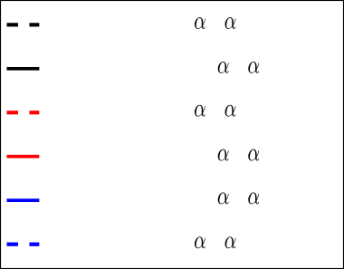

Numerical solution 2= 3=0.9

Proposed closed form 2= 3=0.9

Numerical solution 2= 3=0.6

Proposed closed form 2= 3=0.6

Proposed closed form 2= 3=0.1

Numerical solution 2= 3=0.1

6

5

4

L/n

3

2

1

0

0 0.1 0.2 0.3 0.4 0.5 0.6 0.7 0.8 0.9 1

C

* + - 1. Non-quantized Frame length

12

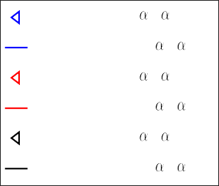

Numerical solution 2= 3=0.9

Proposed closed form 2= 3=0.9

Numerical solution 2= 3=0.6

Proposed closed form 2= 3=0.6

Numerical solution 2= 3=0.1

Proposed closed form 2= 3=0.1

10

8

6

L/n

4

2

0

0 0.1 0.2 0.3 0.4 0.5 0.6 0.7 0.8 0.9 1

C

t

* + - 1. Quantized Frame Length

Figure 5.14: Frame length comparison between the proposed formula and the numerical solution versus the SNR using the strongest tag reply receiver.

20

SNR=4dB

SNR=8dB

SNR=10dB

18

16

Mean reading time Reduction %

14

12

10

8

6

4

2

0

0 100 200 300 400 500 600 700 800 900 1000

No. of tags

Figure 5.15: Mean reading time reduction using the proposed TMCRA com- pared to the conventional frame length *L* = *n* for perfect number of tags esti- mation using *Ct* = 0*.*2

## Mean Reading Time Reduction

Figure 5.15 presents the saved time using the proposed TMCRA compared to the conventional frame length *L* = *n* for perfect number of tags estimation. The simulation results are based on the slot duration constant *Ct* = 0*.*2, as it is considered as a practical value used in the EPCglobal class 1 gen 2 standards

[11] and different values of *SNR*, as each SNR leads to corresponding values for the collision recovery coefficients *α*2, *α*3 and *α*4. According to figure 5.15, when the value of the *SNR* increases, the collision recovery probability increases. Hence, the mean reduction in reading time also increases.

Figure 5.16 shows the percentages of saving time using the proposed TM- CRA compared to the conventional frame length *L* = *n* using different anti- collision algorithms with *Ct* = 0*.*2 and strongest tag reply receiver with average *SNR* = 8 dB which is corresponding to *α*2 = 0*.*52, *α*3 = 0*.*45 and *α*4 = 0*.*35.

According to figure 5.16, the mean reading reduction in reading time for differ- ent estimation algorithms is between 10% and 18%. FSA with perfect number of tags estimation algorithm leads to less number of iterations in the reading

50



Lower bound Schoute Biased chebyshev

MFML

proposed ML estimation Perfect estimation

40

Mean reading time reduction

30

20

10

0

0 100 200 300 400 500 600 700 800 900 1000

Number of tags

Figure 5.16: Mean reading time reduction using the proposed TMCRA com- pared to the conventional frame length *L* = *n* using different anti-collision algorithms with *Ct* = 0*.*2 and *SNR* = 10 dB

process. Thus it results the lower bound of the mean reduction in reading time. On the other hand, FSA with simple estimation algorithm e.g. Lower bound leads to more number of iteration and higher percentage of saving time.

# Comparison of the Proposed Algorithms

The most crucial performance metric in RFID systems is the average total read- ing time for an existing number of tags in the reading area. This section will summarize the performance of the DFSA with the proposed frame lengths. It compares between the average total reading time of the proposed frame lengths and the conventional one which assumes that *Lopt* = *n*. Furthermore, it illus- trates how far are the proposed systems compared to the theoretical lower limit of the EPCglobal C1 G2 standard [11], which gives the minimum identification time for UHF RFID system. The theoretical lower limit is achieved when the system identifies a single tag per slot. Therefore, the minimum number of slots to identify *n* tags is *n* successful slots.

Figure 5.17 shows the simulation results of the average reading time for DFSA using the following parameters: Slots duration constant *Ct* = 0*.*2, with *te* = 60 *µ*s , *tc* = 360 *µ*s, and *ts* = 1060 *µ*s, which are the practical values from real measurements using a Universal Software Defined Radio Peripheral (USRP

2.4

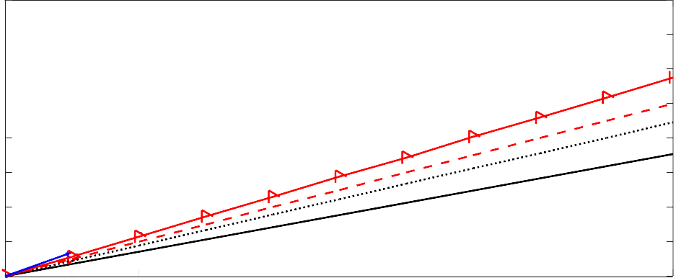

Theoretical lower limit Time and multiple collision recovery Time and constant collision recovery

Time and no collision recovery Conventional system

2.1

Average reading time [Sec]

1.8

1.5

1.2

0.9

0.6

0.3

0

0 100 200 300 400 500 600 700 800 900 1000

Number of tags

* + 1. Using simple number of tags estimation algorithm (Lower bound)

2.4



Theoretical lower limit Time and multiple collision recovery Time and constant collision recovery

Time and no collision recovery Conventional system

2.1

Average reading time [Sec]

1.8

1.5

1.2

0.9

0.6

0.3

0

0 100 200 300 400 500 600 700 800 900 1000

Number of tags

1. Using the proposed collision recovery aware ML number of tags estimation algorithm

Figure 5.17: Average reading time of the proposed systems, conventional FSA and the theoretical limit

B210) [63]. Strongest tag reply receiver is used with average *SNR* = 10 dB, which leads to the following collision recovery coefficients, *α*2 = 0*.*6, *α*3 = 0*.*5, *α*4 = 0*.*4.

Figure 5.17a shows the average reading time for DFSA using lower bound number of tags estimation algorithm. The main objective of theses simulations is to evaluate the performance of the proposed frame lengths formulas without the effect of the proposed ML number of tags estimation algorithm. As dis- cussed in chapter 4, the lower bound number of tags estimation neglects the collision recovery capability of the physical layer and gives the minimum num-

ber of remaining tag in the reading area. According to figure 5.17a, the Time Aware frame length proposal gives 16 % saving in the average total reading time compared to the conventional FSA. The Time and Constant Collision Recov- ery Aware frame length proposal saves 10 % more than the Time Aware frame length, because of the new information about the collision recovery coefficient. In the time and constant collision recovery aware, the average collision recovery probability is *α* = *α*2 = 0*.*6. In case of the time and multiple collision recovery frame length, the algorithm results 30 % average saving in the reading time compared to the conventional DFSA. This is due to considering the different values of the collision recovery coefficients.

Figure 5.17b shows the average reading time with the proposed collision recovery aware ML number of tags estimation. The main target is to evaluate the performance of the proposed frame lengths formulas using the proposed ML number of tags estimation algorithm. According to figure 5.17b, the Time Aware frame length proposal gives 10 % saving in the average total reading time compared to the conventional FSA. The Time and Constant Collision Recovery Aware frame length proposal results 18 % average saving in the reading time compared to the conventional DFSA. The used average collision recovery prob- ability *α* = *α*2 = 0*.*6. In case of the time and multiple collision recovery frame length, the proposed solution results 22 % average saving in the reading time compared to the conventional DFSA.

According to figure 5.17, the percentages of saving in reading time with simple number of tags estimation algorithm is more than the percentages of saving time using the proposed ML number of tags estimation. This is because the total identification time with simple number of tags estimation is more than with the proposed ML number of tags estimation. Thus the number of reading cycles and frame length adaptation with simple number of tags estimation is more than the number of reading cycles with the proposed number of tags estimation. However, the average reading time for DFSA using the proposed frame length formulas with the proposed ML estimation is less than the average reading time with simple number of tags estimation.

Table 5.2 shows a summary of the performance analysis for the proposed frame length formulas with simple number of tags estimation and with ML number of tags estimation.

Table 5.2: Performance analysis for the proposed frame length formulas

1. Average reading time reduction using the proposed frame length formulas compared to the conventional DFSA *L* = *n*

|  |  |  |
| --- | --- | --- |
|  | Simple estimation algorithm (LB) | Proposed ML estimation |
| Time and no CR | 16 % | 10 % |
| Time and constant CR | 25 % | 18 % |
| Time and multiple CR | 30 % | 22 % |

1. Average remaining room of improvement for the proposed frame length formulas to reach the theoretical lower limit of EPCglobal C1 G2

|  |  |  |
| --- | --- | --- |
|  | Simple estimation algorithm (LB) | Proposed ML estimation |
| Time and no CR | 35 % | 20 % |
| Time and constant CR | 25 % | 15 % |
| Time and multiple CR | 15 % | 10 % |

According to the above results, there is still *≈* 10 % can be improved be- tween the proposed systems and the theoretical limit of the EPCglobal C1 G2 standard [11]. The main reason of this is, the allowed optimization was only in the reader side. To follow the EPCglobal C1 G2 standard [11], the tags could not be modified. Thus in the next chapter, backwards compatible improvement of the EPCglobal Class 1 Gen 2 standard will be proposed. This proposed sys- tem is compatible with the EPCglobal C1 G2 standards, i.e. the proposed tags could be jointly operated with conventional tags and identified by conventional readers without affecting the performance. Additionally, conventional tags can also be operated together with the proposed tags and can be identified by the proposed reader.